**Exercise 3: Stored Procedures**

**Scenario 1:** The bank needs to process monthly interest for all savings accounts.

**Question:** Write a stored procedure **ProcessMonthlyInterest** that calculates and updates the balance of all savings accounts by applying an interest rate of 1% to the current balance.

**SOLUTION SCRIPT**

CREATE OR REPLACE PROCEDURE ProcessMonthlyInterest IS

BEGIN

FOR RECORD IN (

SELECT CUSTOMERID FROM CUSTOMERS

FOR UPDATE

) LOOP

UPDATE CUSTOMERS

SET BALANCE = BALANCE + BALANCE * 0.01

WHERE CUSTOMERID = RECORD.CUSTOMERID;

END LOOP;

COMMIT;

END;

/

-- or

CREATE OR REPLACE PROCEDURE ProcessMonthlyInterest IS

BEGIN

UPDATE CUSTOMERS

SET BALANCE = BALANCE + BALANCE * 0.01;

COMMIT;

END;

BEGIN

ProcessMonthlyInterest;

END;

**OUTPUT**

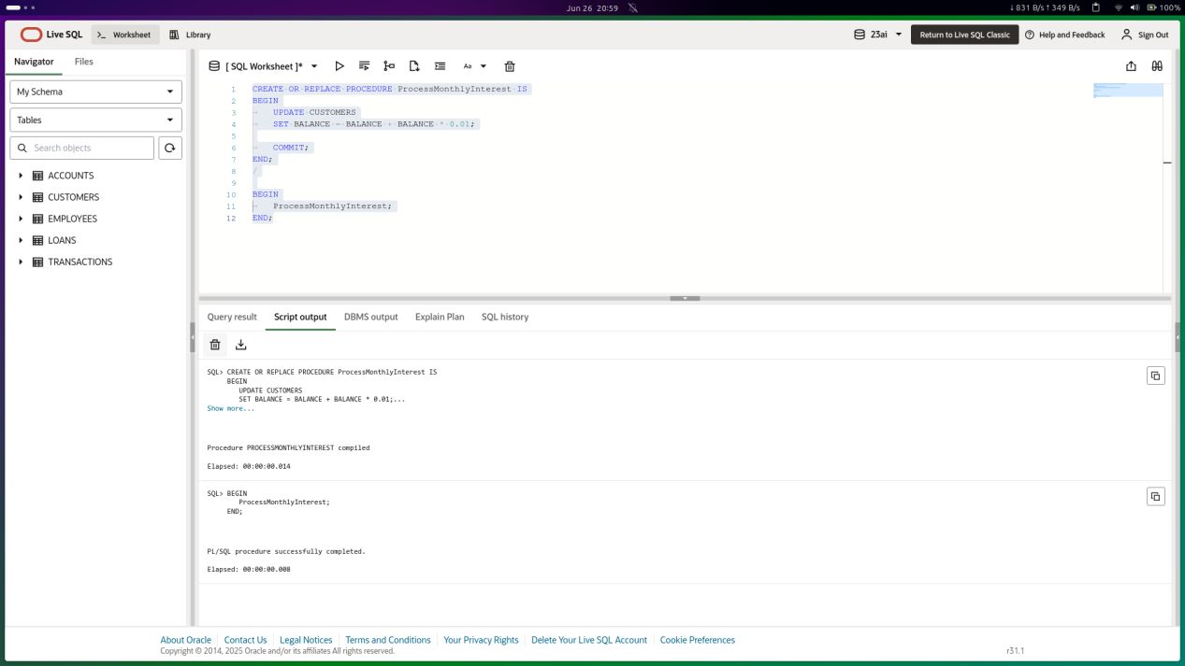

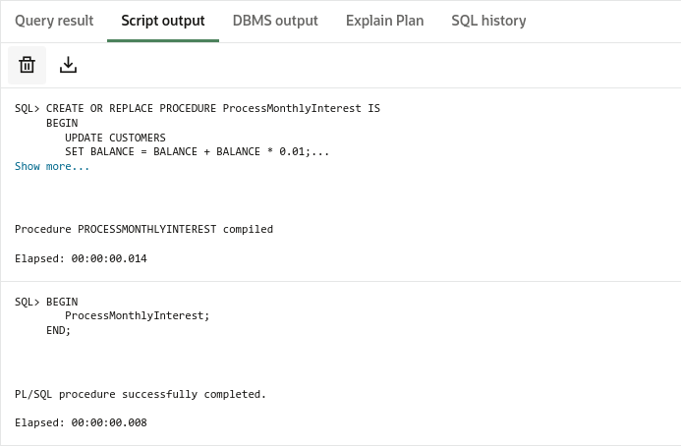

**Scenario 2:** The bank wants to implement a bonus scheme for employees based on their performance.

**Question:** Write a stored procedure **UpdateEmployeeBonus** that updates the salary of employees in a given department by adding a bonus percentage passed as a parameter.

**SOLUTION SCRIPT**

CREATE OR REPLACE PROCEDURE UpdateEmployeeBonus (

dept_name IN VARCHAR2,

bonus_percent IN NUMBER

) IS

BEGIN

FOR RECORD IN (

SELECT EMPLOYEEID FROM EMPLOYEES

WHERE DEPARTMENT = dept_name

FOR UPDATE

) LOOP

UPDATE EMPLOYEES

SET SALARY = SALARY + SALARY * (bonus_percent/100)

WHERE EMPLOYEEID = RECORD.EMPLOYEEID;

END LOOP;

DBMS_OUTPUT.PUT_LINE('Bonus added to ' || dept_name || ' Employees!');

END;

BEGIN

UpdateEmployeeBonus(dept_name => 'IT', bonus_percent => 10);

END;

**OUTPUT**

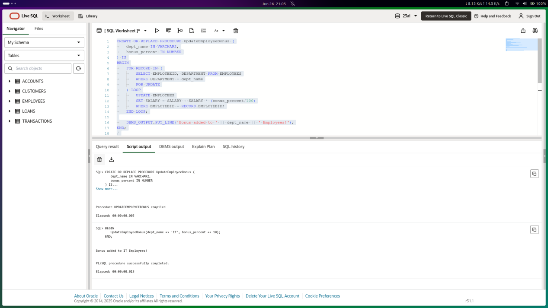

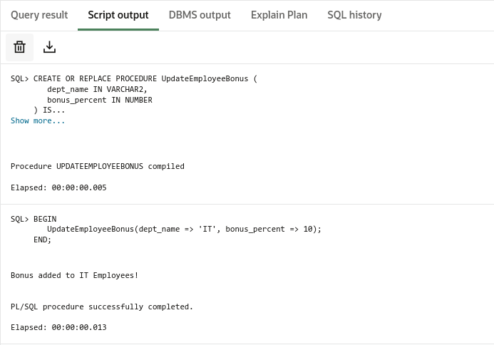

**Scenario 3:** Customers should be able to transfer funds between their accounts.

**Question:** Write a stored procedure **TransferFunds** that transfers a specified amount from one account to another, checking that the source account has sufficient balance before making the transfer.

**SOLUTION SCRIPT**

CREATE OR REPLACE PROCEDURE UpdateEmployeeBonus (

dept_name IN VARCHAR2,

bonus_percent IN NUMBER

) IS

BEGIN

FOR RECORD IN (

SELECT EMPLOYEEID FROM EMPLOYEES

WHERE DEPARTMENT = dept_name

FOR UPDATE

) LOOP

UPDATE EMPLOYEES

SET SALARY = SALARY + SALARY * (bonus_percent/100)

WHERE EMPLOYEEID = RECORD.EMPLOYEEID;

END LOOP;

DBMS_OUTPUT.PUT_LINE('Bonus added to ' || dept_name || ' Employees!');

END;

BEGIN

UpdateEmployeeBonus(dept_name => 'IT', bonus_percent => 10);

END;

**OUTPUT**

